**BA (Hons) Fine Art - Module FA102 - Semester 1 2015-16**

**Assignment 3: Reading a Single Work of Art**

**Antonia Eden**

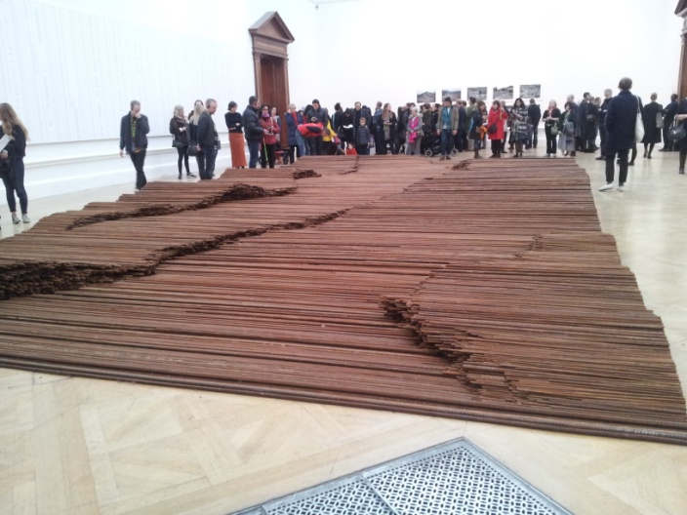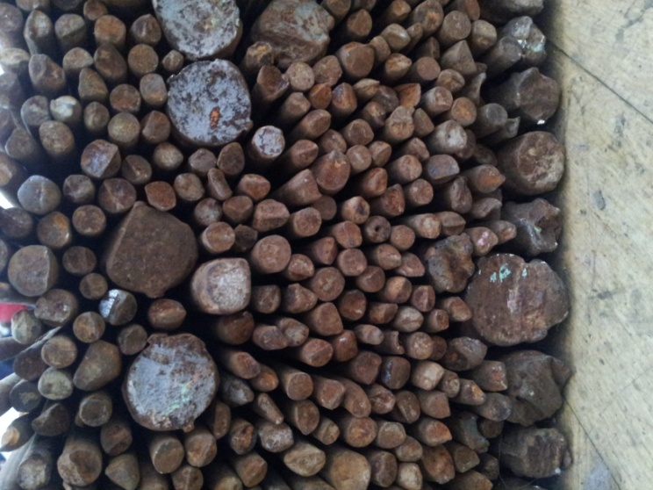

**Straight - 2008–2012**

The largest room in the gallery is home to Straight. A 1200 x 600 cm rectangle of steel reinforcing bars laid out like a carpet on the gallery’s wooden floor**.** The edges of the rectangle are straight and neat. These edges contain individual rebar rods which have been stacked to create waves or ripples running through the piece to give it variety of form. No higher than your knees these rods rise and fall at a low level through the length of the piece with subtle edges being created within the rectangle by careful stacking and composition of shorter rods laid horizontally. The piece is freestanding in as much as it makes use of no other materials to fence it in.

This rectangular carpet of steel set in this large room works as a sculptural abstract piece yet provokes intrigue.

From a distance the piece is like a sea of rusty brown with glints of a brighter, cleaner material sparkling in certain areas. Closer, you discover that these rebars have been used before. The bars bear marks of a previous life. They look rescued from a construction graveyard; some bars still have the faint bend or twist, some have spiral patterns, some have blobs of crude steel or slight discrepancies. Each rebar has been re-straightened meticulously, with care and precision. Bars are formally grouped according to their thickness. The way that they have been laid out is so considered and careful as if each bar holds great importance and fragility. Each bar has its’ own profile at the edges of the rectangle to signify the individuality of each piece.

Although huge in scale the low level composition gives the piece a calming understated feel. Were the rods upright it would be a confrontational piece, yet this piece is submissive and slightly sombre. This arrangement of material evokes many feelings; the ripples created appear to move like a thick viscous liquid wave across the floor yet these ripples could be seen as geographical contours within a landscape.

Either side of the sculpture on the wall are panels filled with names. These names are of over 5,000 children from the Sichuan province who were killed in an earthquake. A video at one side of the room documents the earthquake. The video is horrific to watch. It shows moments after the earthquake, the rubble has just fallen and bodies of young children are being pulled out from the mess, there is chaos and dust and women crying and wailing over limp bodies. It was so upsetting to watch and I couldn’t help but cry. The video goes on to document the governmental cover up to conceal not only the scale of death but also the failing of these cheap and corner cutting construction methods.

The bars that are laid out on the floor are the very same rebars that were recovered from the earthquake that killed all these children.

This knowledge transforms this beautiful and abstract sculpture into a monument to those who have died. It becomes a public place to mourn, to bow our heads with respect to view it, to sit beside it and look closer so that we can try to understand and reflect. These bars take on a different meaning, the care in which they have been laid out and stacked comes to symbolise the laying out of the dead bodies. Respect for each lost life has been reflected in the time and consideration given to straighten and reform each distorted, twisted and scrapped rod.

Straight stands as a monument to those who lost their lives in this tragic earthquake. It becomes a commentary on a government who failed its’ people. By using the very same bars that caused such a huge loss of life, yet treating them with such care and respect, the artist highlights the contradiction in how these people were treated by the Chinese government.

Even though it is huge in scale it creates an intimate and isolated place. There is a feeling of hush that descends on the room. However, due to the popularity of the show, there were many visitors on the day I visited. People congregated around the video, some sit on the floor close to the piece, others are taking selfies. If the viewer was on their own or perhaps when the show wasn’t so busy it would be easier to contemplate more, to hear the ripples, the silence. Perhaps this is what was intended. Regardless, this huge sculpture set in the largest room on one of the busiest days was able to reduce me to tears. It can’t help but evoke sadness and loss, a true memorial to all those lost.